The basic course of Action for elevator scenario:

•  Passenger presses floor button (that is the button on the wall).

•  Elevator system detects floor button pressed.

•  Elevator moves to the floor.

•  Elevator doors open.

•  Passenger gets in and presses elevator button (that is the button in the cabin panel).

•  Elevator doors close.

•  Elevator moves to required floor.

•  Elevator doors open.

•  Passenger gets out.

• Elevator doors close.

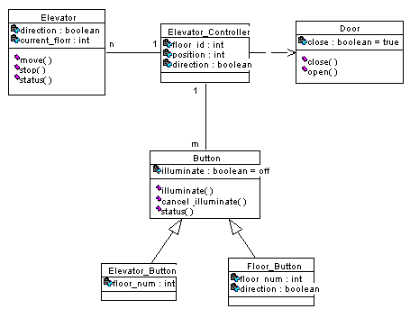

1. Draw the Sequence diagram pertaining to the floor button.

